Week 1 Readings and Assignments
Complete the following reading early in the week:
- Week 1 online lectures
- Week 1 film:
  - Either Paths of Glory (Kubrick, 1957) or Citizen Kane (Welles, 1941)
- From your textbook, Exploring Digital Cinematography, read the following chapters:
  - The Digital Cinematographer
  - Visual Storytelling
  - Directing the Camera—A Traditional Filmmaking Perspective
- From your textbook, The 3ds Max 2010 Bible, read the following chapter:
  - Configuring and Aiming Cameras
Watch the film Paths of Glory by Stanley Kubrick, paying close attention to the courtroom scene, which you'll need to analyze in the discussion questions assignment.
If you are unable to find the film Paths of Glory by Stanley Kubrick, watch Citizen Kane by Orson Welles. Pay close attention to the first scene that opens with a child shown playing in the snow—the camera then slowly pulls out to reveal three adults in serious conversation in the foreground and a playing child in the background.
Assignment Summary: Week 1 | Due Date
Assignment 1: Autobiography | Tuesday, April 6, 2010
Assignment 2: Discussion Questions | Thursday, April 8, 2010
Assignment 3: Depth and Mood | Saturday, April 10, 2010

For your projects you'll be working out of 3ds Max. The learning center has excellent tutorials and is a great resource for software questions you may have.
Every assignment has a Pro Tip: as the first post. Read these, as they will tell you what I want from each assignment. They will also help clarify some of the more confusing aspects of the assignment. Be aware that some assignments ask for "animations" but to post files in jpg or pdf. I have gone through and tried to clarify each of these assignments in the PRO TIPs but if I have missed something please ask me to clarify it for you!! There are no stupid questions in my class.
Feel free to ask me questions and please look to your fellow classmates as problem solvers as well. The better feedback you give each other as well as what comes from me, the better your work will be. This class should be a place where each of you can critique freely on each others work and expect that same kind of critique for your work. It is only through a serious discussion of each others projects that they will improve

Week 1 Overview
Storytelling has been one of the oldest and most pleasurable leisure activities of all time. Over the years, it has assumed a number of forms, coming a long way from cave paintings and early verbal forms. One of the turning points in the world of storytelling was the invention of a device—the camera.
With the invention of the camera, people could suddenly "see" a scene instead of imagining it in their minds. The effect of an image captured by a camera captivated everyone's imagination and started a technological revolution taking storytelling to yet another form—the films.
Starting as a cottage industry roughly 100 years ago, filmmaking has become a lucrative moneymaking venture in the last five decades. Today, people don't read as much they used to; they don't even listen to music for the story experiences as they once did. Instead, they prefer watching films in a theater, on the television sets, and even on their laptops! This art of using films to show a story gives rise to a number of questions:
What makes the viewer feel the story?
How does a director make a viewer live in the world of his creation?
Films and games form the perspective of the viewer through the story experience.
Films are the visual representation of the mental and emotional intent and the experiences of the writer or director. A lot of research and effort goes into bringing out the intent of the filmmaker. Therefore, in the world of films and animation, having a good story is extremely important to portray the desired intent using the tools of filmmaking and animation. These same building blocks of story are found in games. Both art forms have a necessity to enthrall their viewers or players in the story. In looking at the foundations of film production, we will begin to understand what is required to build a great story world in games.
During the next six weeks, we will investigate, research, and experiment with film scenes and three-dimensional (3-D) scene design to engross our players’ senses. We will take a close look at the camera and the use of light to enliven our scenes. This course will familiarize you with the standard camera and lighting techniques, but the emphasis will be on experimentation and application of these skills to a 3-D environment. This will not only help you to acquire new skills, but also develop your perspective towards this art form.
Because people learn best by sharing knowledge, this course also provides an excellent platform to interact and share your ideas with other students. So, let's explore the world around us and learn from each other's experiences.
Learning Outcomes:
Know how to use the essential components of the software-animation environment to create compelling imagery.


The Power of a Camera
Each image captured by a camera is a story in itself. Weaving a complete story with these individual images requires imagination and insight into human emotions and behavior. While reading a story, we view the story through our mind's eye, imagining ourselves in the unfolding events. The story coaxes the reader into a state of acceptance and willing participation that ideally brings him or her so close to the perspective of the protagonist that the two ultimately become one. Games take this step further, as more often than not, you are the protagonist. Arguably then, the need for imagination to keep the player enthralled in the story is just as great, and the reading of it remains generally the same.
Typically, a reader filters the written story through a three-step process:
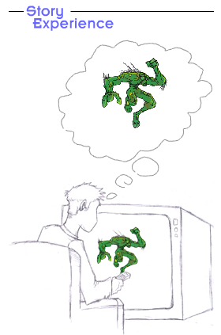
The sensory phase: In this first phase, the viewer is presented with basic information about the story through sound, pictures, symbols, and other tactile phenomenon.
The brain/imagination phase: In this second phase, the information is absorbed and processed in the viewer's brain. At this critical point, the viewer tries to associate the information received in the sensory phase with his own experiences and construct an acceptable, though highly subjective reality.
Immersive experience phase: Finally, the viewer establishes a relation with the story and starts "living" the story.
What does the camera mean to me?
In films and games, the viewer views the story through the lens of the camera. Acting as the eye to view the story, the lens leaves very little for the viewer to imagine. The mediums enable the viewer to go straight from the sensory phase to the immersive experience phase—completing the filtering cycle in just two steps. This makes it doubly important for the camera to capture the right frame, time, and the language of the scene.

The Language of the Film Frame
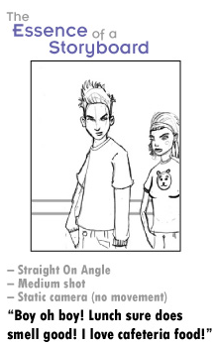
The narration of the story becomes simpler with the use of the camera. However, capturing the essence of the story through the eye of camera is a comprehensive task that demands a lot of time, energy, and coordination of the production team. Unlike books, narrating stories through films or computer graphic (CG) animations involves a number of phases—starting from scripting and storyboarding to producing and editing.
In this context, if the script is the master story document, the storyboard is the master visual document for the film that is used by directors to convey the visual story information effectively and concisely to the film crew. Here it is understood that a storyboard that leaves room for too much interpretation can be detrimental to the final production phase in which schedules are tight and budgets are often even tighter.
Because good planning makes for smooth filming or game production (not that production is ever truly smooth) it is up to you, the CG artist, or storyboard artist to make sure that the language the director uses for the shot directions matches the language spoken by the crew responsible for the shot. This is something that applies to everyone from preproduction to postproduction.
To achieve the goal of a common language, it is ideal to convey four key pieces of information with every drawn panel:
- Scale: How big is the subject in the frame?
- Angle: How high, low, far to the right, or left is the camera in relation to the subject?
- Camera movement: Where does the camera movement start and where does it end?
- Dialog: Which words spoken in the scene will dictate the pace of editing or camera movement?
With these four pieces of information, it would be difficult for anyone to misinterpret the intent of the director for the scene. Let's take a closer look at each of these.

Scale
In real life, our field of vision is usually broad; we rarely look so closely at another person that the person fills our entire field of vision. The only time we take such an intimate view is when we are with people with whom we share close emotional bonds. Scale determines the distance between viewer and the subject, and it provides the means through which a director can define the level of intimacy between them.

Types of Scales:
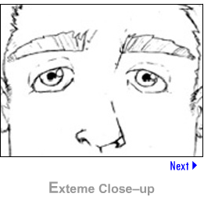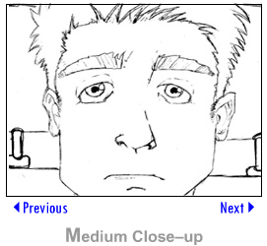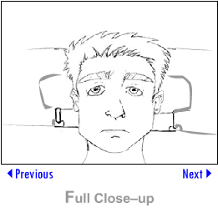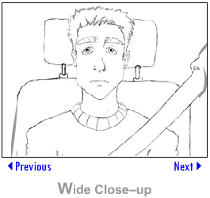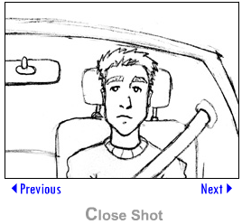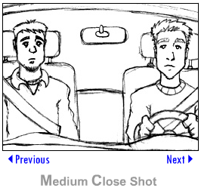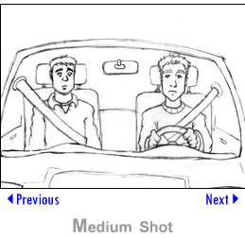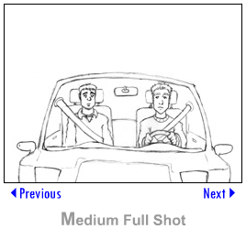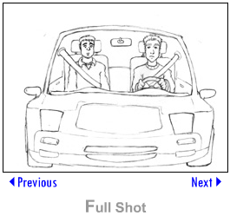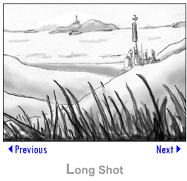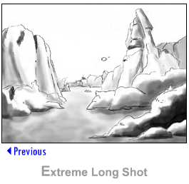

Subjective vs Objective shots
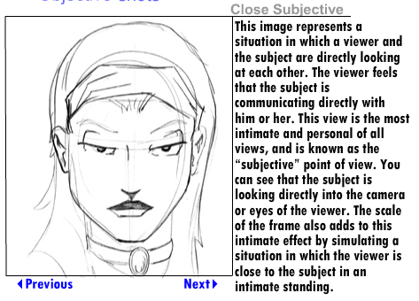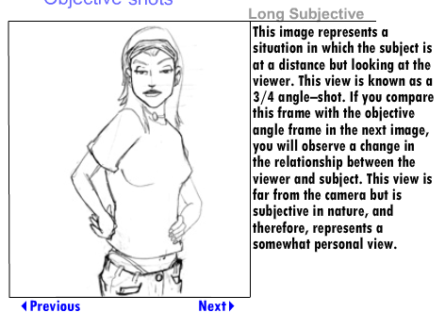
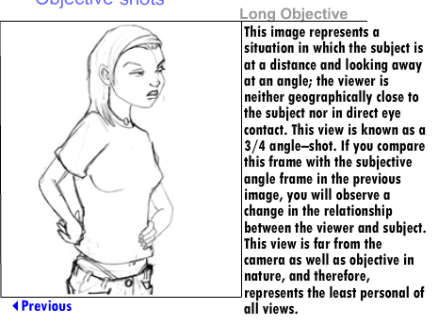
The opposite holds true as well. When a camera is placed far from the subject to make the subject appear small in the frame, it makes the viewers see the subject as something that is far removed from their existence.
In this context, it is important to note that the type of lens used in the camera will also affect the nature of scale in a frame. With a long lens in a small room, the viewer will only see a small part or corner of the room. With a shorter, wider lens, the viewer is privy to much more visual information with the objects in foreground appearing quite large in comparison to those in the background.

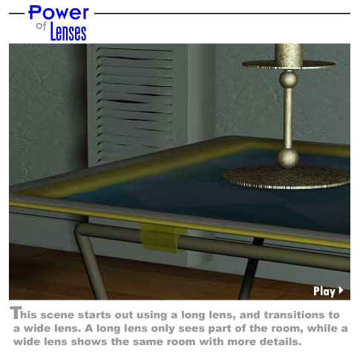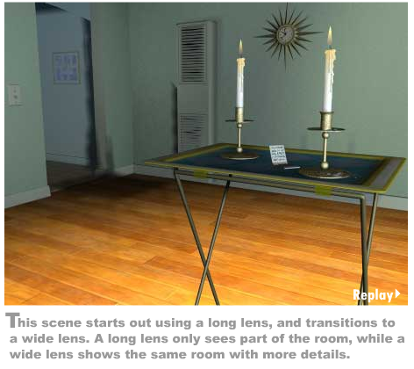
Angle
Though angle depicts the point of view (POV) of the viewer, it is often considered the least-utilized aspect of camera manipulation and placement in film. There can be several reasons for this.
Because we see the world at eye level, many viewers find any angles other than eye level to be disorienting and uncomfortable. Also, an average film camera is a cumbersome item; it is often a laborious task to move the camera into positions other than those at eye level.
The fact remains that the height of the camera above ground level and its angle in relationship to the ground should reflect a real-life situation. For example, placing a camera at the eye level of a standing person actually appears too high most of the time.
In the scenes involving children or subjects of smaller height, which camera angle will yield a most neutral, personal, and friendly shot, in your opinion?
Because games use a virtual camera, some of these reasons don’t apply, and they allow for unique situations that might not otherwise be found in films. For example, in Call of Duty 4 World and War, the camera allows for an angle of crawling on the ground. This type of camera angle is extremely rare in films, but because there is no cumbersome equipment that must be physically dragged across the floor, it is easier to achieve in games.
What other camera angles would be easier to achieve in games as opposed to films?

Camera Angles:
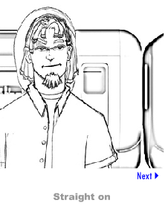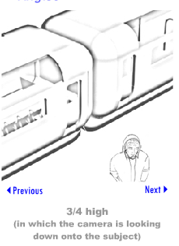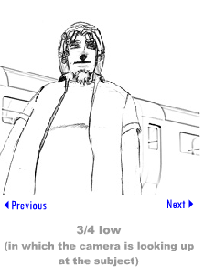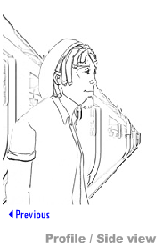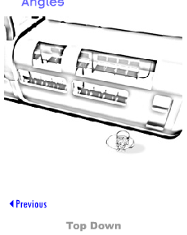
Camera Movement
The language of camera movements in relation to the filmmaking process is something that tends to change from person to person. For instance, in traditional animation, the term "truck in" is used in place of the term "dolly in." The meanings and visual effects of both these camera movements are virtually identical.
It's quite easy to remember the visual effects from their terms, because the nomenclature generally refers to the devices used to achieve the camera effect or motion. For instance, to "dolly in" means to move the camera toward the subject of the shot. This shot got its name from the tracks (resembling train tracks) on which the camera was placed to achieve the effect. The camera was considered the "train," and because tracks were commonly referred to as "dolly tracks," the movement was termed "dolly in."
One can make similar connections in relation to many other camera movements. The crane shot, for example, is a camera mounted on a computer-controlled crane, like those found on construction sites, simply smaller and more agile.
Dialog
Dialog is often used as a cue to signal a particular action or event in a film, and therefore it is a very important part of the shot description. Simply quoting the dialog or the segment of the dialog that is critical to initiate an action or event is sufficient for the needs of an average film storyboard.
Consider a scene in which the word "run" by the supporting character causes the protagonist to run toward the exit. In this scene, quoting the word "run" will help visualize the timing and pacing of the scene.

Movement:
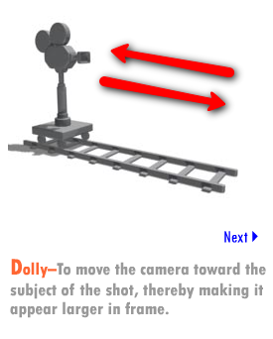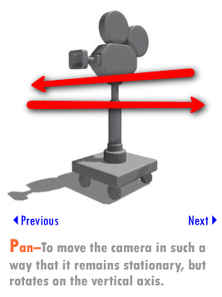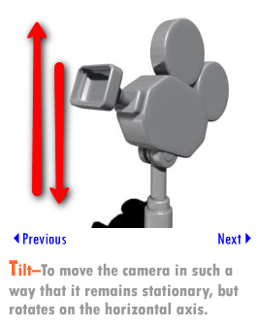
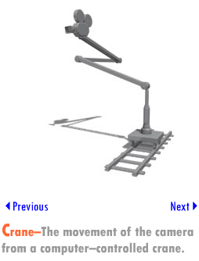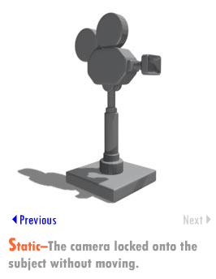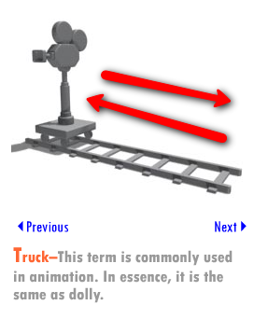
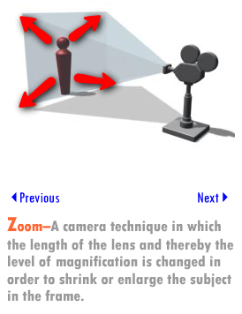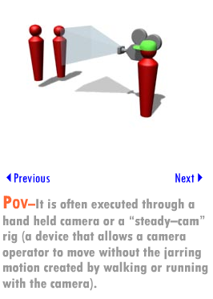

Basic Elements of Composition
Let's review basic compositional concepts, specifically how they relate to a frame.
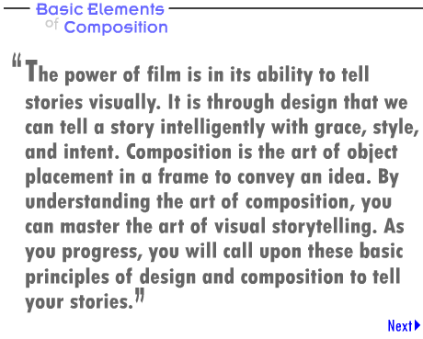

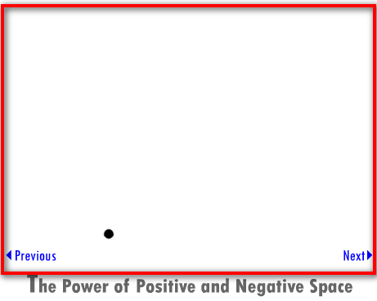

The Power of Positive and Negative Space
Positive and negative spaces in a frame are the basic levels of value upon which a composition can be judged. It is through this relationship between the objects of opposing value that the eye perceives the rhythm, unity, or motion of a frame. In the instance of a frame that is primarily white with a small speck of black in the bottom of the frame, the viewer is left with a feeling of isolation and loneliness.
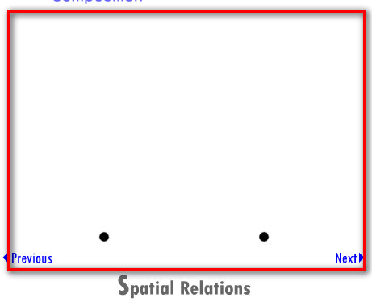

Spatial Relations
Add another small speck to the frame. Is there less of a feeling of isolation?
This is an example of how spatial relationships can dictate the emotional content of a simple scene. We have moved from a single isolated subject in the frame to two subjects that have the potential to communicate, relate to each other in some way, or interact. On its most basic level, this is the power of composition. By simply adding a new subject, we can give some meaning to the scenario.
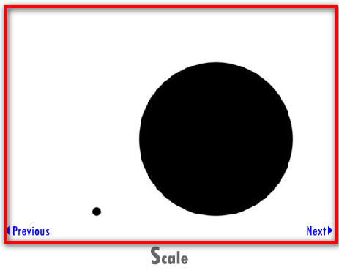

Scale
Now, suppose we change the scale of one of these subjects. What do you observe? By changing the scale, we have changed the nature of the relationship between the two subjects. The larger of the two subjects becomes the dominating member of the pair. Scale can be used effectively to change the importance or focus of a particular part of an image.
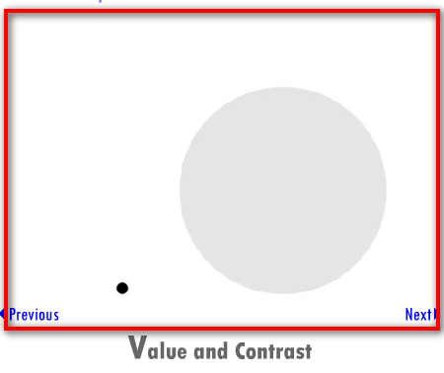

Value and Contrast
Until this point in our exercise, we've only used maximum contrast. Observe what happens when we change the value of the larger subject in the shot.
The importance of that larger subject has changed. It has now taken a back seat to the smaller object by virtue of its lighter value and resulting lower contrast. The visual relationship has changed between the two subjects, and so too has their relationship.

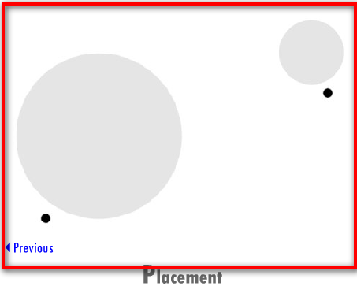

Placement
Now let's look at what happens when we add more subjects to our frame. But this time, we'll change their placement in relation to each other.
By arranging the scene as shown, we have created a situation in which there are two distinct groups in a frame, each with relationships within their respective groups. Placement has the power to create more complicated and diverse relationships as the number of subjects in a frame increases.

Basic Elements of Lighting
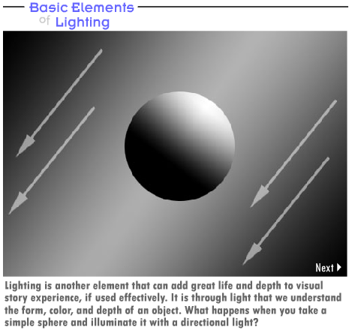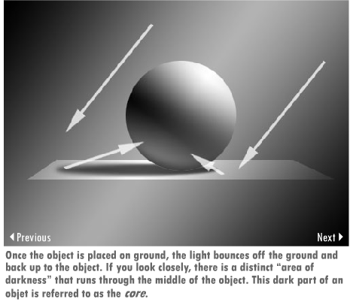
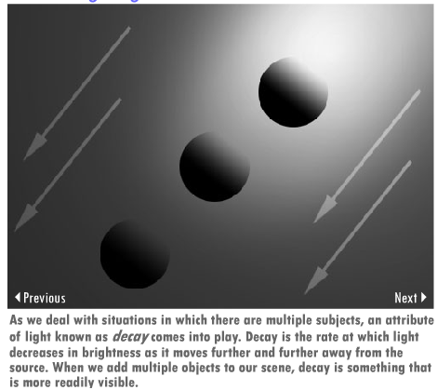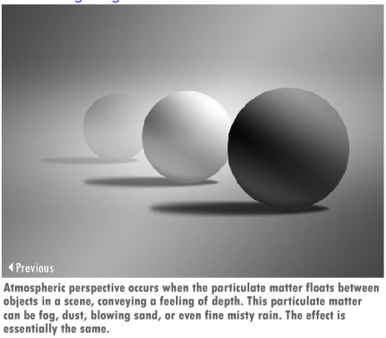
When transferred to the CG venue, the skillful use of these elements will enable you to set up shots that show a great deal of depth. All of these are easily emulated in the CG realm, and they all can simulate reality. A heavy fog can convey the feeling of a gloomy morning, while effectively placed lights with well-executed decay can make for a spooky night. But none of these is useful if not used wisely and in the context of the story.

Summary
This week, we've explored the language of film, specifically how it speaks to us on a global scale. We examined how the medium of film has changed and how we perceive and enjoy stories as a collective audience. From there, we moved on to a more specific view of the language of filmmakers and their films. It is this "language of films" that you will use to communicate with your peers throughout your career. As with any other language, using it often and using it fluently will also help you to become a successful visual storyteller. As storytellers, this language provides us the means to share our thoughts and imagination with our viewers and players. So learn to speak it well.
Assignment 1: Autobiography
Introduce yourself to the class by providing the following details:
- Name
- Description of the one activity that you enjoy most while creating a scene
- Post any one animated sequence that you have created
- Share your experience about the lighting and camera techniques that you used in the posted animated sequence
- Provide your feelings about your strengths and areas of concern in terms of knowledge and experience, including how you think this course will help you overcome your weak areas and enhance your skills
Post your autobiography in a Word document to this Discussion Area by Friday, May 14, 2010. Share your animated sequence on the W1: Assignment 1 Doc Sharing folder. Review and comment on the autobiographies of other students by the end of the week.
Assignment 1 Grading Criteria | Maximum Points
Provided the required information. | 4
Posted one animated sequence. | 4
Analyzed the strengths and areas of concern and provided logical expectations from this course. | 4
Interacted with other students in the class. | 4
Total: | 16
For assistance with any problems you may have when completing this assignment—OR—to offer your assistance to classmates, please use theProblems and Solutions Discussion area located through the left side navigation link.
Assignment 2: Discussion Questions
By Sunday, May 16, 2010, go to the Discussion Area and post responses to two of the discussion questions assigned by the facilitator. All responses should be posted to this Discussion Area.
By Monday, May 17, 2010, begin commenting on at least two of your peers' responses. You can ask technical questions or respond generally to the overall experience. Be objective, clear, and concise. Always use constructive language, even in criticism, to work toward the goal of positive progress. Submit your responses to the appropriate topic in this Discussion Area.
Assignment 2 Grading Criteria | Maximum Points
Response Criteria
Met the criteria for the correct responses to the questions assigned. | 4
Used vocabulary relevant to the current week's topics—at least four terms. | 4
Participation Criteria
Used vocabulary relevant to the current week's topics—at least four terms. | 4
Participated in the discussion by asking a question, providing a statement of clarification, providing a point of view with rationale, challenging a point of discussion, or making a relationship between one or more points of the discussion. | 4
Justified ideas and responses by using appropriate examples and references from texts, Web sites, and other references or personal experience. | 4
Total: | 20
For assistance with any problems you may have when completing this assignment—OR—to offer your assistance to classmates, please use theProblems and Solutions Discussion area located through the left side navigation link.

DQ 1- Language of the film frame
Focusing on the courtroom scene in Paths of Glory by Stanley Kubrick or the opening scene of a child playing outside in Citizen Kane by Orson Welles, comment on the following four topics:
Placement of camera
Point of view
Movement of camera
Sound lighting techniques
You may base your comments on the following statements if you’ve chosen Paths of Glory:
The placement of camera in the scene
The effect of the placement and point of view of the camera in the scene
As an animator, how could you have shot the scene differently? Why? How did the lighting in the film affect the way the story was told? Did it help the intent of the film?
You may base your comments on the following statements if you’ve chosen Citizen Kane:
The choice of camera and lighting in the scene
The effect of camera movement on the theme of the scene
The use of camera in pulling the story along

DQ 2 – Composition is the art of arrangement
While every eye sees something different, most eyes will agree on what they are seeing or how they are being guided across an image. Referencing the lecture from earlier in the week, discuss which compositional tool is most intriguing or which of them are new to you.

DQ 3 – Cinematographic Elements and Artistic choices
When listing your favorite films, explain why one sticks out as a film that truly inspired your creative instincts, influencing you as an artist, as far as your aesthetic sense is concerned. What cinematographic features of the film drew you to it? Was there something that was happening in your life that influenced this opinion?
Note: Despite the personal nature of these questions, you will find that life experiences often have a great deal to do with their artistic choices. So, try to think why the film inspired you in the way it did.

DQ 4 – Camera and Lighting Techniques
Think of a game character you've created in one of your previous courses and choose three positive and three negative traits for this character. How will you create an atmosphere to highlight these traits in this character using camera and lighting? Support your answer with reasons and if possible sketches.
Note: Try to choose unique character traits that aren't commonly used or easily depicted. This will enable you to hone your skills in the finer aspects of using camera and lighting for characterization.
Assignment 3: Depth and Mood
Using the primitives in your 3-D modeling application, build six simple scenes to convey depth and mood. Use the following effects in your scenes:
- Perspective
- Atmosphere (fog, rain, and fire)
- Layout (the use of object placement in fore-/mid-/background)
- Color (warm vs. cool)
- Shadow (cast shadows as a tool to describe form)
- Value (dark to light to show change over distance on a shape/scene)
Observe and document how each of these effects convey depth and mood.
Save your scenes as Scene1_First name, Scene2_First name. For example, if your name is John, you can save an animation as Scene1_John. Submit your file as a JPG, PDF, or a ZIP containing your files.
By Tuesday, May 18, 2010, post the rendered scenes and your observations to thisDiscussion Area. Review and critique the work of at least two other students as early as possible and comment on the way they have used various effects to convey depth and mood. Then, revise your work based on the peer reviews you have received and, after incorporating the changes, post it in the W1: Assignment 3 Doc Sharingfolder by the end of the week.
Note: Discuss any challenges you encounter in this assignment or any other assignment in this course in the Problems and Solutions Discussion Area. Also share useful tips and tricks and possible solutions to problems posted by your peers in this forum.
The Problems and Solutions Discussion Area will be present each week. Therefore, take advantage of this discussion forum as much as possible.
Assignment 3 Grading Criteria | Maximum Points
Posted six scene renderings of simple geometric shapes on a plane displaying each with a different concept of depth or mood. (6 x 4 points for each scene) | 24
Analyzed how the use of each effect created a distinct mood. (6 x 4 points for each effect) | 24
Actively participated in the discussion and provided constructive comments for the posts of at least two other participants. (2 x 4) | 8
Actively participated in the Problems and Solutions Discussion Area. | 4
Total: | 60
For assistance with any problems you may have when completing this assignment—OR—to offer your assistance to classmates, please use theProblems and Solutions Discussion area located through the left side navigation link.
Pro Tip
Please post your files here to the DISCUSSION BOARD

